**Extension Activities are carried out in the neighborhood community, sensitizing students to social issues, for their holistic development and impact**

**2016-2017**

* National Pharmacy Week (NPW) was celebrated at Dr. B. C. Roy College of Pharmacy and AHS., Durgapur dated on 25th November 2016. The program was inaugurated by Mrs. Mitra, Member, BCREC Society. A rally for the purpose of diabetes prevention with the slogan “**Walk for Diabetes”** was led by Prof (Dr.) S. Chakraborty, Director, BCRCP and Dr. S Ray, Principal, BCRCP with all faculties and students visited nearby society as well as hospitals like ESI Hospital, Vivekananda Hospital Pvt. Ltd., Sub-Divisional Hospital Durgapur, The Mission Hospital etc.
* In the 2nd half of 25th November 2016, eminent specialists of The Mission Hospital, Dr. D. De, Heamatologist and Dr. R. Mukhopadhyay, Endocrinologist talked on “**Thalassemia and Diabetes”.**
* On 26th November, a social activity for **“Free Health Camp”** was arranged in the college campus for the people of the nearby slum in collaboration with The Mission Hospital Durgapur.

**Walk for Diabetes**

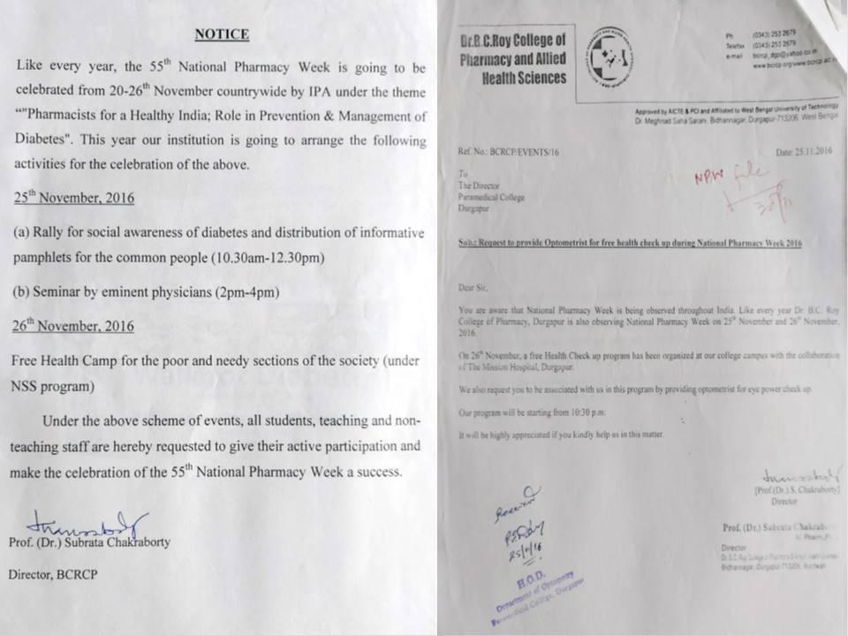

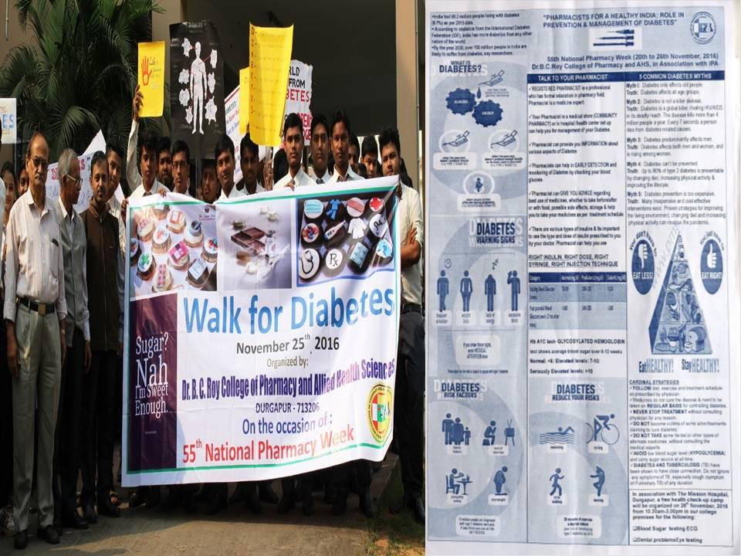

**Free Health Camp**

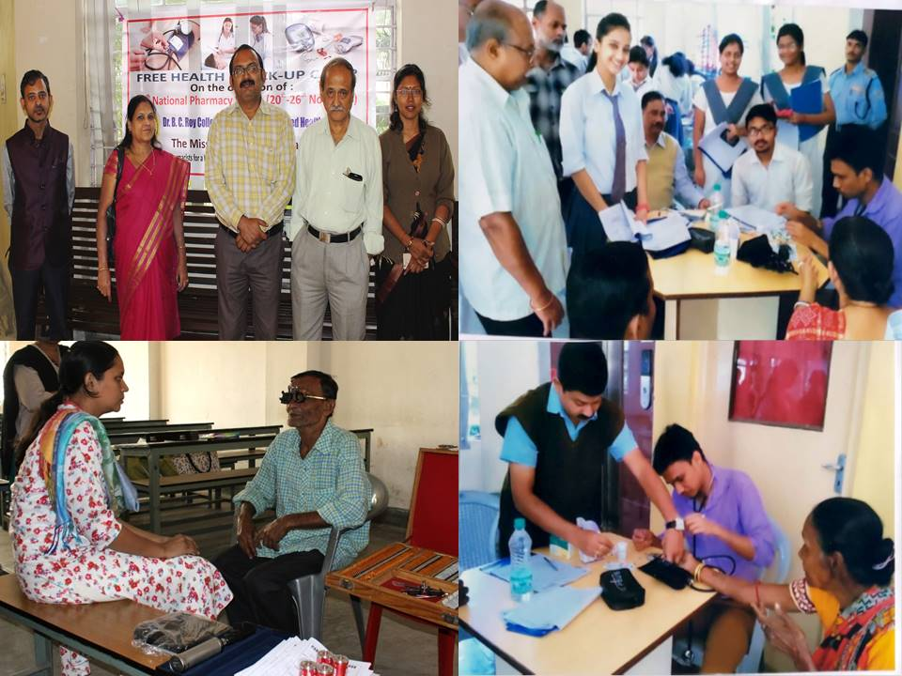

**2017-2018**

* As a part of “**Community Service”**, Dr. B. C. Roy College of Pharmacy and AHS. organized an event for the differently abled students of **HOPE School, Durgapur**. Thirty candidates aged 8 to 18 years with their teachers performed in the program to show their skills in areas such as singing, dancing, puppet show, aerobics, painting, playing musical instruments etc. As a token of appreciation the President of Dr. B. C. Roy College of Pharmacy and AHS handed over Rs 50,000 to the HOPE School as an acknowledgement for their participation and performance at our institution in the year 2017.

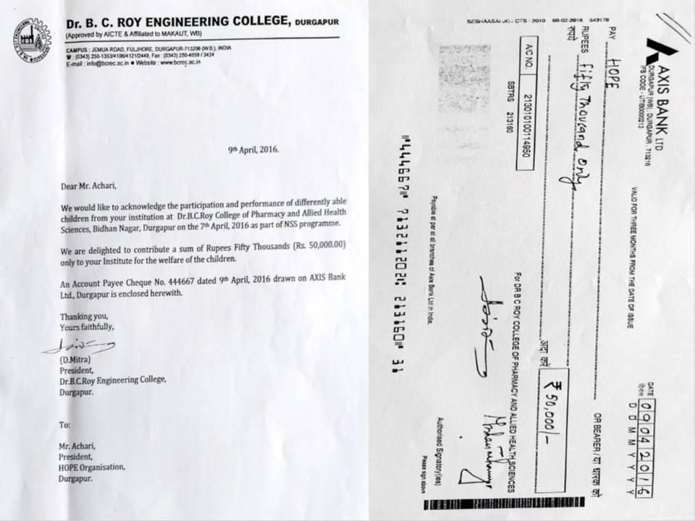

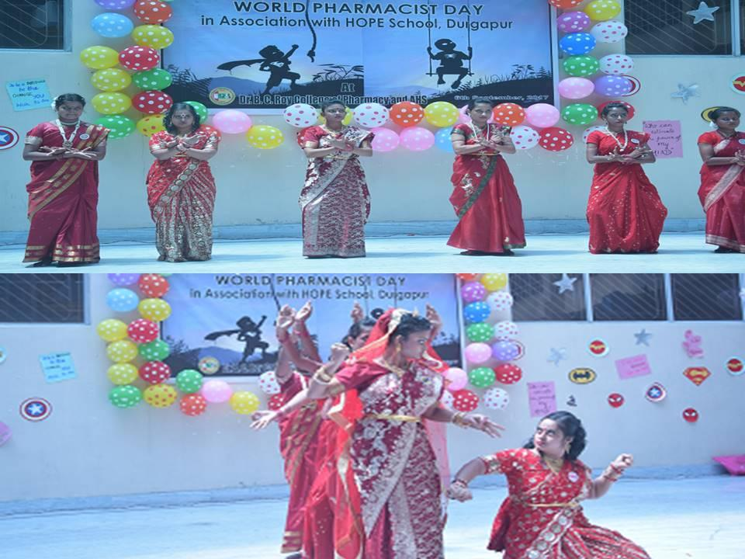

**2018-2019**

# **Blood Donation Camp:**

# Dr. B. C. Roy College of Pharmacy and AHS organized “Blood Donation Camp” in association with ‘THE MISSION HOSPITAL’, Durgapur, on 6th April, 2019. More than 100 students and faculties voluntarily donated blood and contributed to our campaign “**Donate Blood and Save Life**”.

# 

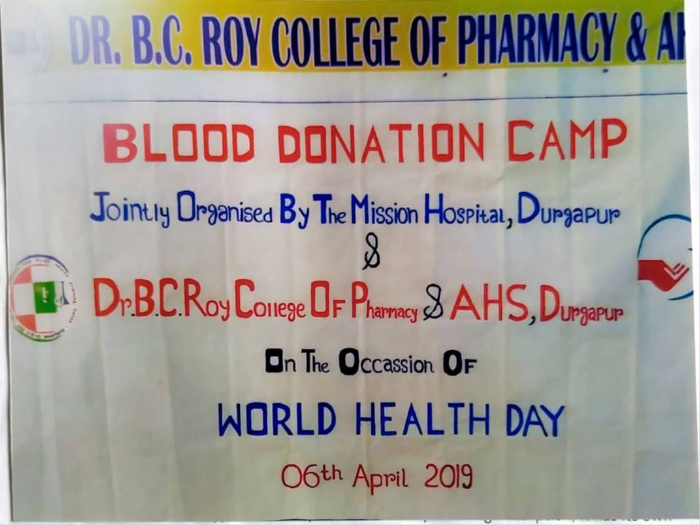

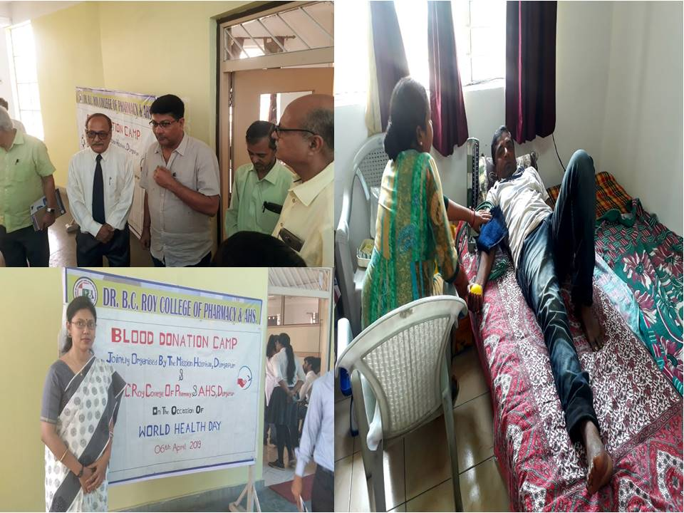

**2019-2020**

* As a part of “**Community Service”**, a unit of “**Pradhan Mantri Bharatiya Janaushadhi Kendra (PMBJK)**” was established and successfully run by Dr. B. C. Roy College of Pharmacy and AHS. The main aim of this unit is to make the generic medicines easily available at an affordable price to the community.
* Free check up campaign for blood sugar & blood pressure were organized occasionally through this unit as a part of community service at Dr. B. C. Roy College of Pharmacy and AHS., Durgapur.

