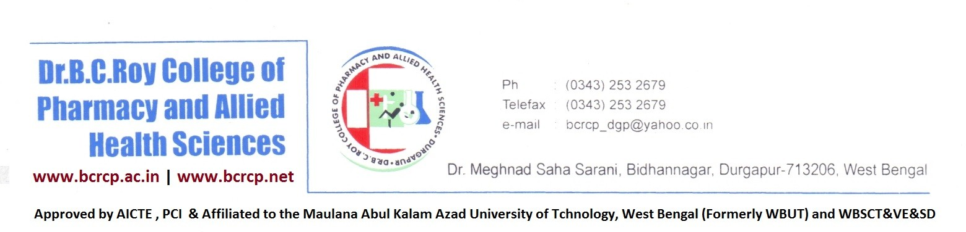

**Annual Report of Anti-Discrimination Cell for the Academic Year 2023-24**

In the academic year 2023-24, Anti-Discrimination Cell (ADC) of Dr. B. C. Roy College of Pharmacy and Allied Health Sciences, Durgapur, W.B., organized meetings at regular intervals with the committee members and students to monitor that the anti-discrimination policies of the college are being properly followed and implemented as also to outline and plan the ways to raise awareness among students regarding various modalities of reporting and resolving any issues of discrimination. The meetings were held regarding various academic and non-academic matters, proper guidance, encouragement of the students belonging in different categories such as general, minority, backward community, differently able and girl. No issues have been raised regarding discrimination among students for this academic year, which indicate a positive environment. An awareness program was conducted on 1st March, 2024 on the topic of ‘ZERO DISCRIMINATION DAY’2024’ and the theme was “To protect everyone’s health, protect everyone’s rights”.

This ADC has planned to organize the next meetings in the months of November, February and April respectively for the coming academic year 2024-25 to look after any issues of the depriving students, to ensure conducive environment for academic growth of the students. ADC has also planned to conduct an awareness program.

Dr. Sudip Kumar Mandal (In-charge)

Anti-Discrimination Cell