**ANNUAL GENDER SENSITIZATION ACTION PLAN**

**AY 2023-2024**

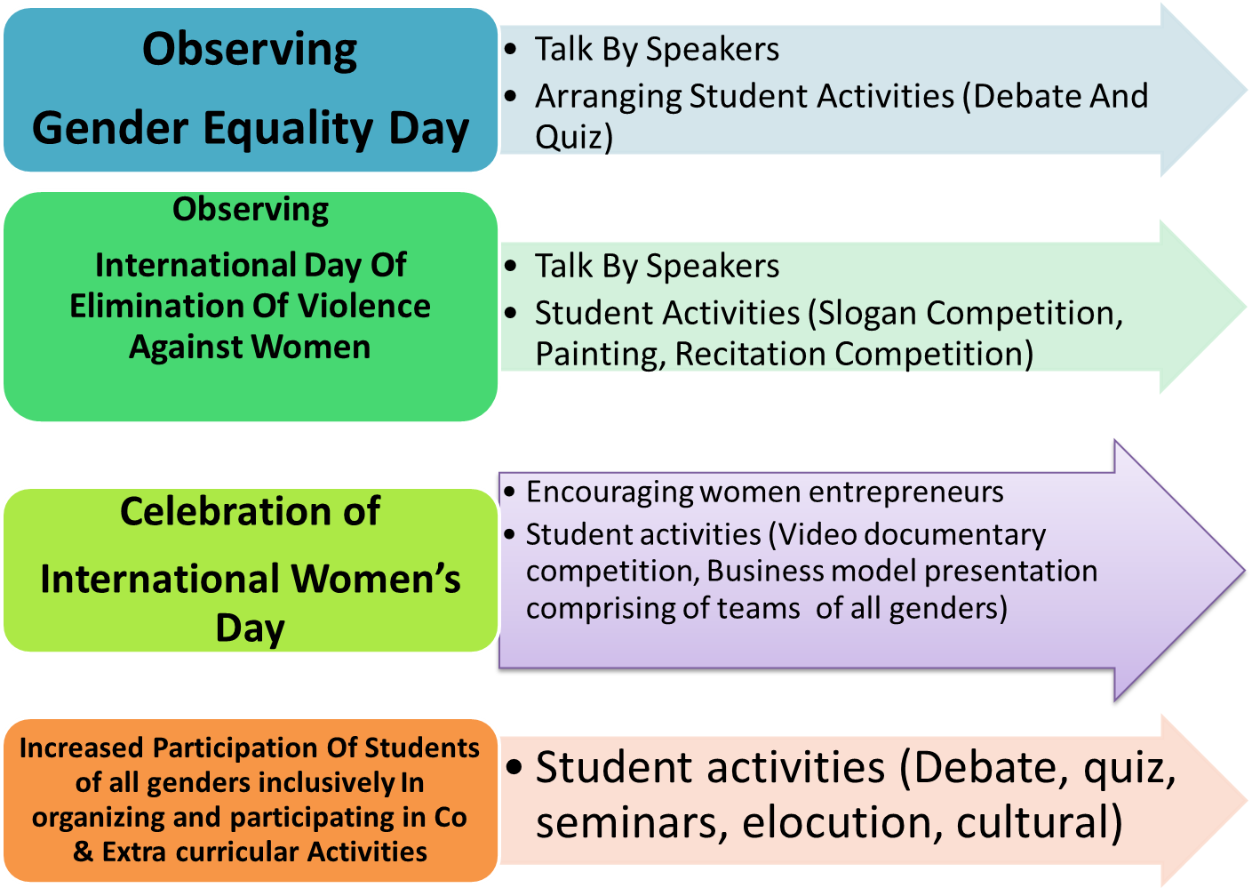

# Besides, the institute arranges health camps, blood donation camps, Yoga classes and special grooming classes for all genders.

**GENDER INCLUSIVE PROGRAMS HELD IN AY 2023/2024**

| **Sr. No.** | **Event** | **Date** | **Notice/ Minutes** | **Attendance** | **Images** | **Reports** |
| --- | --- | --- | --- | --- | --- | --- |
|  | Induction Program- Elocution Competition On Women In Equality/ Talk On Importance Of Soft Skills And Personality Development In Career Growth/ Women's Equality Day | 24th Aug/ 27th Aug 2023 | <https://www.bcrcp.ac.in/NAAC/AQAR23-24/CR-7/7.1/7.1.8/Supporting%20Documents/NOTICE/INDUCTIONPROGRAM.pdf> | <https://www.bcrcp.ac.in/NAAC/AQAR23-24/CR-7/7.1/7.1.8/Supporting%20Documents/ATTENDANCE/INDUCTIONPROGRAMD6.pdf> | <https://www.bcrcp.ac.in/NAAC/AQAR23-24/CR-7/7.1/7.1.8/Supporting%20Documents/UPLOAD%20PHOTO/Women_s%20equality%20day.jpg> | <https://www.bcrcp.ac.in/NAAC/AQAR23-24/CR-7/7.1/7.1.8/Supporting%20Documents/REPORTS/INDUCTIONPROGRAM.pdf> |
|  | Induction Program- Yoga Session By Mr. Tarun Mukherjee | 28th Aug 2023 | <https://www.bcrcp.ac.in/NAAC/AQAR23-24/CR-7/7.1/7.1.8/Supporting%20Documents/ATTENDANCE/INDUCTIONPROGRAMD8.pdf> | <https://www.bcrcp.ac.in/NAAC/AQAR23-24/CR-7/7.1/7.1.8/Supporting%20Documents/UPLOAD%20PHOTO/INDUCTION-YOGA.jpg> |
|  | Induction Program-  National Sports Day | 29th Aug 2023 | <https://www.bcrcp.ac.in/NAAC/AQAR23-24/CR-7/7.1/7.1.8/Supporting%20Documents/ATTENDANCE/NSpD.pdf> | <https://www.bcrcp.ac.in/NAAC/AQAR23-24/CR-7/7.1/7.1.8/Supporting%20Documents/UPLOAD%20PHOTO/National%20Sports%20Day%20(August%2029,2023).jpg> | <https://www.bcrcp.ac.in/NAAC/AQAR23-24/CR-7/7.1/7.1.8/Supporting%20Documents/REPORTS/NSpD.pdf> |
|  | Cultural Event /Biswakarma Puja | 18th Sept 2023 | <https://www.bcrcp.ac.in/NAAC/AQAR23-24/CR-7/7.1/7.1.8/Supporting%20Documents/NOTICE/Viswakarma%20puja.pdf> | <https://www.bcrcp.ac.in/NAAC/AQAR23-24/CR-7/7.1/7.1.8/Supporting%20Documents/ATTENDANCE/BISWAKARMAPUJA.pdf> | <https://www.bcrcp.ac.in/NAAC/AQAR23-24/CR-7/7.1/7.1.8/Supporting%20Documents/UPLOAD%20PHOTO/VISWAKARMA%20PUJA%20(1).jpg> | <https://www.bcrcp.ac.in/NAAC/AQAR23-24/CR-7/7.1/7.1.8/Supporting%20Documents/REPORTS/BISWAKARMAPUJA.pdf> |
|  | Seminar On Business Communication And Soft Skills Enhancement By Debadrita Sen | 22nd Sept 2023 | - | <https://www.bcrcp.ac.in/NAAC/AQAR23-24/CR-7/7.1/7.1.8/Supporting%20Documents/ATTENDANCE/BUSINESS%20COMMUNICATION%20AND%20SOFT%20SKILLS%20SEMINAR.pdf> | <https://www.bcrcp.ac.in/NAAC/AQAR23-24/CR-7/7.1/7.1.8/Supporting%20Documents/UPLOAD%20PHOTO/SEMINAR%20ON%20BUSINESS%20COMMUNICATION%20SKILLS.jpg> | <https://www.bcrcp.ac.in/NAAC/AQAR23-24/CR-7/7.1/7.1.8/Supporting%20Documents/REPORTS/BC&SS.pdf> |
|  | Fresher’s Welcome For D. Pharm, B. Pharm And M. Pharm Final Year Batches | 13th Oct 2023 | <https://www.bcrcp.ac.in/NAAC/AQAR23-24/CR-7/7.1/7.1.8/Supporting%20Documents/NOTICE/FRESHERSWELCOME%20(1).pdf> | <https://www.bcrcp.ac.in/NAAC/AQAR23-24/CR-7/7.1/7.1.8/Supporting%20Documents/ATTENDANCE/FRESHERSWELCOME%20(2).pdf> | <https://www.bcrcp.ac.in/NAAC/AQAR23-24/CR-7/7.1/7.1.8/Supporting%20Documents/UPLOAD%20PHOTO/FRESHER_S%20WELCOME(1).jpg> | <https://www.bcrcp.ac.in/NAAC/AQAR23-24/CR-7/7.1/7.1.8/Supporting%20Documents/REPORTS/FRESHER_SWELCOME.pdf> |
|  | National Youth Day/ Vigyan Jyoti Program/Ushna (Winter  Cloth Distribution) | 11th Jan 2024 | <https://www.bcrcp.ac.in/NAAC/AQAR23-24/CR-7/7.1/7.1.8/Supporting%20Documents/NOTICE/Notice_youth%20day.pdf> | <https://www.bcrcp.ac.in/NAAC/AQAR23-24/CR-7/7.1/7.1.8/Supporting%20Documents/ATTENDANCE/NATIONAL%20YOUTH%20DAY.pdf> | <https://www.bcrcp.ac.in/NAAC/AQAR23-24/CR-7/7.1/7.1.8/Supporting%20Documents/UPLOAD%20PHOTO/National%20Youth%20Day.jpg> | <https://www.bcrcp.ac.in/NAAC/AQAR23-24/CR-7/7.1/7.1.8/Supporting%20Documents/REPORTS/NYD.pdf> |
|  | Republic Day | 26th Jan 2024 | <https://www.bcrcp.ac.in/NAAC/AQAR23-24/CR-7/7.1/7.1.8/Supporting%20Documents/NOTICE/Republic%20day.pdf> | <https://www.bcrcp.ac.in/NAAC/AQAR23-24/CR-7/7.1/7.1.8/Supporting%20Documents/ATTENDANCE/RD.pdf> | <https://www.bcrcp.ac.in/NAAC/AQAR23-24/CR-7/7.1/7.1.8/Supporting%20Documents/UPLOAD%20PHOTO/Republic%20Day.jpg> | <https://www.bcrcp.ac.in/NAAC/AQAR23-24/CR-7/7.1/7.1.8/Supporting%20Documents/REPORTS/RD.pdf> |
|  | Cultural Event/Basant Panchami | 14th Feb 2024 | <https://www.bcrcp.ac.in/NAAC/AQAR23-24/CR-7/7.1/7.1.8/Supporting%20Documents/NOTICE/notice%20_Saraswati%20puja.pdf> | <https://www.bcrcp.ac.in/NAAC/AQAR23-24/CR-7/7.1/7.1.8/Supporting%20Documents/ATTENDANCE/SARASWATI%20PUJA.pdf> | <https://www.bcrcp.ac.in/NAAC/AQAR23-24/CR-7/7.1/7.1.8/Supporting%20Documents/UPLOAD%20PHOTO/Saraswati%20Puja.jpg> | <https://www.bcrcp.ac.in/NAAC/AQAR23-24/CR-7/7.1/7.1.8/Supporting%20Documents/REPORTS/BASANTPANCHAMI.pdf> |
|  | Celebration Of International Mother Language Day | 21st Feb 2024 | <https://www.bcrcp.ac.in/NAAC/AQAR23-24/CR-7/7.1/7.1.8/Supporting%20Documents/NOTICE/notice%20_international%20Mother%20language%20day.pdf> | <https://www.bcrcp.ac.in/NAAC/AQAR23-24/CR-7/7.1/7.1.8/Supporting%20Documents/ATTENDANCE/INTERNATIONAL%20MOTHER%20LANGUAGE%20DAY.pdf> | <https://www.bcrcp.ac.in/NAAC/AQAR23-24/CR-7/7.1/7.1.8/Supporting%20Documents/UPLOAD%20PHOTO/INTERNATIONAL%20MOTHER%20LANGUAGE%20DAY.PNG> | <https://www.bcrcp.ac.in/NAAC/AQAR23-24/CR-7/7.1/7.1.8/Supporting%20Documents/REPORTS/INTERNATIONAL%20MOTHER%20LANGUAGE%20DAY.pdf> |
|  | National Science Day | 28th Feb 2024 | <https://www.bcrcp.ac.in/NAAC/AQAR23-24/CR-7/7.1/7.1.8/Supporting%20Documents/NOTICE/notice_national%20science%20day.pdf> | <https://www.bcrcp.ac.in/NAAC/AQAR23-24/CR-7/7.1/7.1.8/Supporting%20Documents/ATTENDANCE/NScD.pdf> | - | <https://www.bcrcp.ac.in/NAAC/AQAR23-24/CR-7/7.1/7.1.8/Supporting%20Documents/REPORTS/NSD.pdf> |
|  | National Pharmacy Education Day/ Constitution Awareness Program | 6th Mar2024 | <https://www.bcrcp.ac.in/NAAC/AQAR23-24/CR-7/7.1/7.1.8/Supporting%20Documents/NOTICE/notice%20_national%20pharmacy%20education%20day.pdf> | <https://www.bcrcp.ac.in/NAAC/AQAR23-24/CR-7/7.1/7.1.8/Supporting%20Documents/ATTENDANCE/NEPD.pdf> | <https://www.bcrcp.ac.in/NAAC/AQAR23-24/CR-7/7.1/7.1.8/Supporting%20Documents/UPLOAD%20PHOTO/NATIONAL%20PHARMACY%20EDUCATION%20DAY.PNG> | <https://www.bcrcp.ac.in/NAAC/AQAR23-24/CR-7/7.1/7.1.8/Supporting%20Documents/REPORTS/NPED.pdf> |
|  | Cultural Event /Celebration Of Rabindra Jayanti | 8th May 2024 | <https://www.bcrcp.ac.in/NAAC/AQAR23-24/CR-7/7.1/7.1.8/Supporting%20Documents/NOTICE/notice%20_Rabindrajayanti.pdf> | <https://www.bcrcp.ac.in/NAAC/AQAR23-24/CR-7/7.1/7.1.8/Supporting%20Documents/ATTENDANCE/RABINDRAJAYANTI.pdf> | <https://www.bcrcp.ac.in/NAAC/AQAR23-24/CR-7/7.1/7.1.8/Supporting%20Documents/UPLOAD%20PHOTO/RABINDRA%20JAYANTI.jpg> | <https://www.bcrcp.ac.in/NAAC/AQAR23-24/CR-7/7.1/7.1.8/Supporting%20Documents/REPORTS/RABINDRAJAYANTI.pdf> |
|  | Annual Technical Fest “Zentech” | 15th May 2024 | <https://www.bcrcp.ac.in/NAAC/AQAR23-24/CR-7/7.1/7.1.8/Supporting%20Documents/NOTICE/Zentech_zenith_vedyantra%2024.pdf> | <https://www.bcrcp.ac.in/NAAC/AQAR23-24/CR-7/7.1/7.1.8/Supporting%20Documents/ATTENDANCE/ZENTECH.pdf> | <https://www.bcrcp.ac.in/NAAC/AQAR23-24/CR-7/7.1/7.1.8/Supporting%20Documents/UPLOAD%20PHOTO/ZENTECH(1).jpg> | <https://www.bcrcp.ac.in/NAAC/AQAR23-24/CR-7/7.1/7.1.8/Supporting%20Documents/REPORTS/ZENTECH.pdf> |
|  | Annual Internal Cultural Program “Zenith” | 16th May 2024 | <https://www.bcrcp.ac.in/NAAC/AQAR23-24/CR-7/7.1/7.1.8/Supporting%20Documents/ATTENDANCE/ZENITH.pdf> | <https://www.bcrcp.ac.in/NAAC/AQAR23-24/CR-7/7.1/7.1.8/Supporting%20Documents/UPLOAD%20PHOTO/ZENITH.jpg> | <https://www.bcrcp.ac.in/NAAC/AQAR23-24/CR-7/7.1/7.1.8/Supporting%20Documents/REPORTS/ZENITH.pdf> |
|  | Joint Cultural Fest “Vedyantra” | 17th May 2024 | <https://www.bcrcp.ac.in/NAAC/AQAR23-24/CR-7/7.1/7.1.8/Supporting%20Documents/ATTENDANCE/VEDYANTRA.pdf> | <https://www.bcrcp.ac.in/NAAC/AQAR23-24/CR-7/7.1/7.1.8/Supporting%20Documents/UPLOAD%20PHOTO/VEDYANTRA.jpg> | <https://www.bcrcp.ac.in/NAAC/AQAR23-24/CR-7/7.1/7.1.8/Supporting%20Documents/REPORTS/VEDYANTRA.pdf> |
|  | World Music Day & International Yoga Day | 21st Jun 2024 | <https://www.bcrcp.ac.in/NAAC/AQAR23-24/CR-7/7.1/7.1.8/Supporting%20Documents/NOTICE/notice%20_international%20yoga%20day.pdf> | <https://www.bcrcp.ac.in/NAAC/AQAR23-24/CR-7/7.1/7.1.8/Supporting%20Documents/ATTENDANCE/IYD.pdf> | <https://www.bcrcp.ac.in/NAAC/AQAR23-24/CR-7/7.1/7.1.8/Supporting%20Documents/UPLOAD%20PHOTO/YOGA%20DAY(21st%20June%202024).jpg> | <https://www.bcrcp.ac.in/NAAC/AQAR23-24/CR-7/7.1/7.1.8/Supporting%20Documents/REPORTS/IYD_WMD_merged.pdf> |