04/06/2023

NOTICE

World Environment Day is celebrated annually on 5 June and encourages awareness and action for the protection of the environment. The theme for World Environment Day this year will focus on solutions to plastic pollution under the campaign #BeatPlasticPollution.

BCRCP will celebrate the event on 5th June, 2023. For this occasion, we are going to execute the following activities.

1. Gathering and disposing plastic waste from in and around campus by students from 11.00am onwards.
2. Addressing the theme on World Environment Day at the APC Roy Seminar Hall from 12.00 pm onwards.
3. Design idea competition to reuse plastic for students.



Mrs. Rituparna Chaki Ghosh.   
 Asst. Prof. & In-charge, Event Management Committee, BCRCP.

**PROGRAM SCHEDULE FOR WORLD ENVIRONMENT DAY**

**2K23**

**05TH JUNE 2023**

|  |  |
| --- | --- |
| **Time** | **Details** |
| 11:00 am - 12:00 noon | Gathering and disposing plastic waste from in and around campus by students |
| 12:00 noon - 12: 30 pm | Addressing the theme on World Environment Day at the APC Roy Seminar Hall |
| 12:30 pm - 01:30 pm | Speech on Beat Plastic Pollution by Dr. Souvik Basak, DIC of Pharmaceutical Chemistry. |

**\*\*\*END OF PROGRAM\*\*\***

**Mrs. Rituparna Chaki Ghosh**

In-charge, Event Management Committee, BCRCP

**A REPORT ON WORLD ENVIRONMENT DAY,**

**CELEBRATED ON 05th JUNE, 2023.**

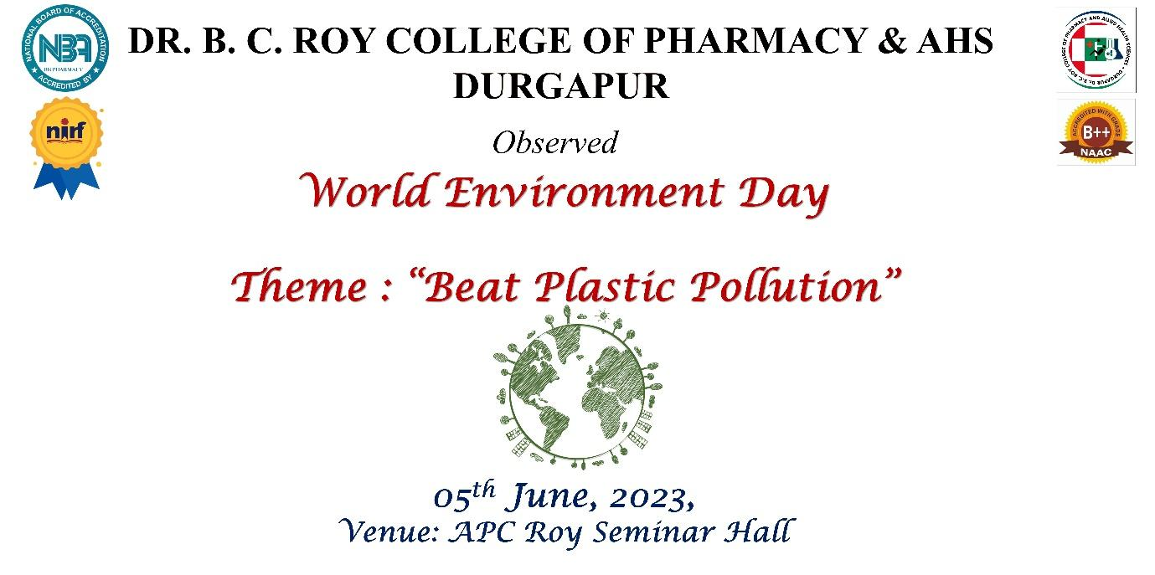

**World Environment Day** (**WED**) is celebrated annually on 5 June and encourages awareness and action for the [protection of the environment](https://en.wikipedia.org/wiki/Environmental_protection). It is supported by many non-governmental organizations, businesses, government entities, and represents the primary [United Nations](https://en.wikipedia.org/wiki/United_Nations) outreach day supporting the environment. First held in 1973, it has been a platform for [raising awareness](https://en.wikipedia.org/wiki/Awareness_raising) on [environmental issues](https://en.wikipedia.org/wiki/Environmental_issues) as [marine pollution](https://en.wikipedia.org/wiki/Marine_pollution), [overpopulation](https://en.wikipedia.org/wiki/Overpopulation), [global warming](https://en.wikipedia.org/wiki/Global_warming), [sustainable development](https://en.wikipedia.org/wiki/Sustainable_development) and wildlife crime. World Environment Day is a global platform for [public outreach](https://en.wikipedia.org/wiki/Public_outreach), with participation from over 143 countries annually. Each year, the program has provided a theme and forum for businesses, [non-government organizations](https://en.wikipedia.org/wiki/Non-governmental_organization), communities, governments and celebrities to advocate environmental causes. World Environment Day was established in 1972 by the [United Nations](https://en.wikipedia.org/wiki/United_Nations) at the [Stockholm Conference on the Human Environment](https://en.wikipedia.org/wiki/United_Nations_Conference_on_the_Human_Environment) (5–16 June 1972), that had resulted from discussions on the integration of human interactions and the environment.

The World Environment Day theme for 2023 is "Solution to plastic pollution" and the event was hosted by Côte d'Ivoire. It is a reminder that people’s actions on plastic pollution matters. The steps governments and businesses are taking to tackle plastic pollution are the consequence of this action. It is time to accelerate this action and transition to a circular economy.

The Management, teaching and non-teaching staffs and the students of Dr. B.C. Roy College of Pharmacy & Allied Health Sciences also observed World Environment Day on 5th of June, 2023 at APC Roy Seminar Hall. The program began with the welcoming of the dignitaries in the dais. Prof. Dr. S. Chakraborty addressed the audience, especially the students with a motivating talk on how can one contribute to save environment from getting polluted and also the role of pharmacists in the protection of environment. The address of the Director was followed by the address of the Principal, Prof. Dr. S. K. Samanta, who also spoke on the different environmental issues that are emerging these days and how the use of plastic is affecting the environment. Mr. Sagar Sengupta made a very significant and interesting contribution. He mentioned how the dumping of the industrial wastes in the river Yamuna has resulted in the depletion of marine ecosystem and also how dumping of plastic wastes in waterbodies has affected marine life. He also spoke about how the industries releases harmful chemical in open environment whenever they get a chance and cause environmental pollution. He also stated that human beings and the use of plastic go hand in hand, and that, since human beings are dependent on the use of plastics, we have to take special care so that it doesn’t pollute the environment. Prof. Dr. S. Ray, Professor-in-Charge, P.G. & Research, also made a significant contribution. He explained how plastics enter into the food chain and affects the health of humans. Students were shown videos on how plastics are affecting the lives of the people in general and how plastics can be recycled.

Dr. Souvik Basak, DIC Pharmaceutical Chemistry & Analysis, spoke on the Management of Plastic waste through microbial cell factory, investigations for a greener but efficient technology, where he explained that Microbial cell factory for biocatalysis often serves as an alternate tool for efficient but greener management of the particular reaction and that they have exploited this tool in their laboratory for management of solid plastic waste. Specific biomedical plastics have been targeted for bioremediation where relevant microbes have been isolated from the same and subjected to programmed bioremediation of the same. The immobilization and other microbial engineering have been adopted to upregulate the plastic degradation efficiency of the cell, which in turn were revealed to have a significant impact over the rate of the reaction. Till date's study, the microbes look safe in animal model with respect to their virulence, not exhibiting much toxicological manifestations in short term basis. It is also imminent that microbes have plastic degradation enzyme that might have potential biomedical applications such as wound healing.

The students of the institution also conducted a cleanliness drive where they collected all the plastic and other wastes to make the college and in turn the environment clean.The program ended with a general note on how human beings can help in reducing plastic wastes and make the world a better place to live in.

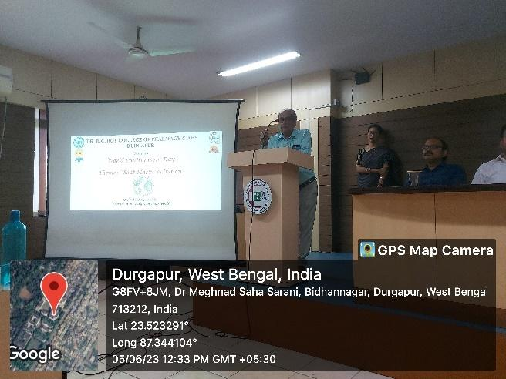 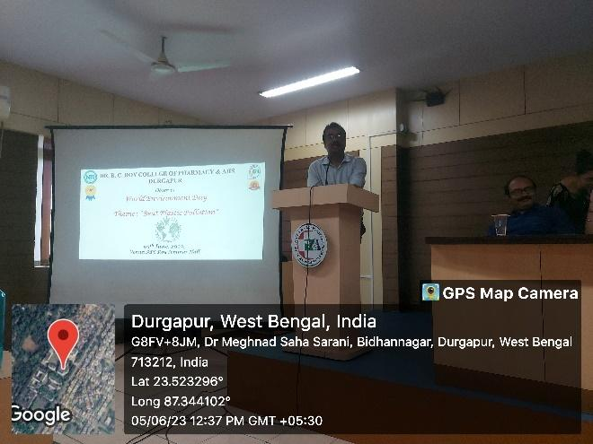

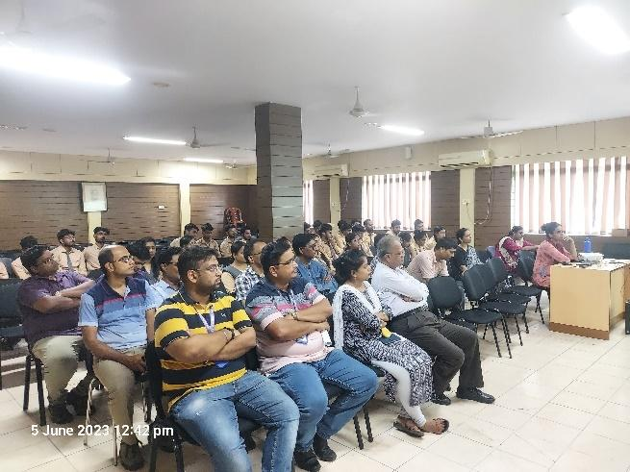 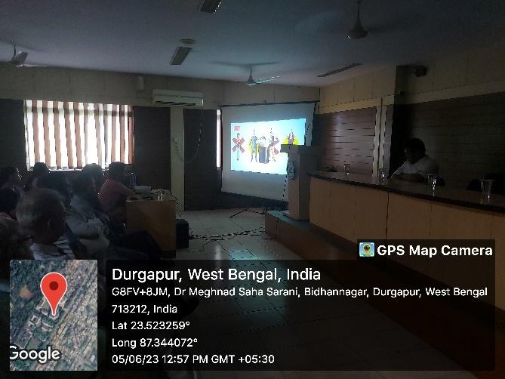

Name of the Event: WORLD ENVIRONMENT DAY.

Date: 05th JUNE, 2023.

Venue: APC ROY SEMINAR HALL.

No. of Participants: 56.