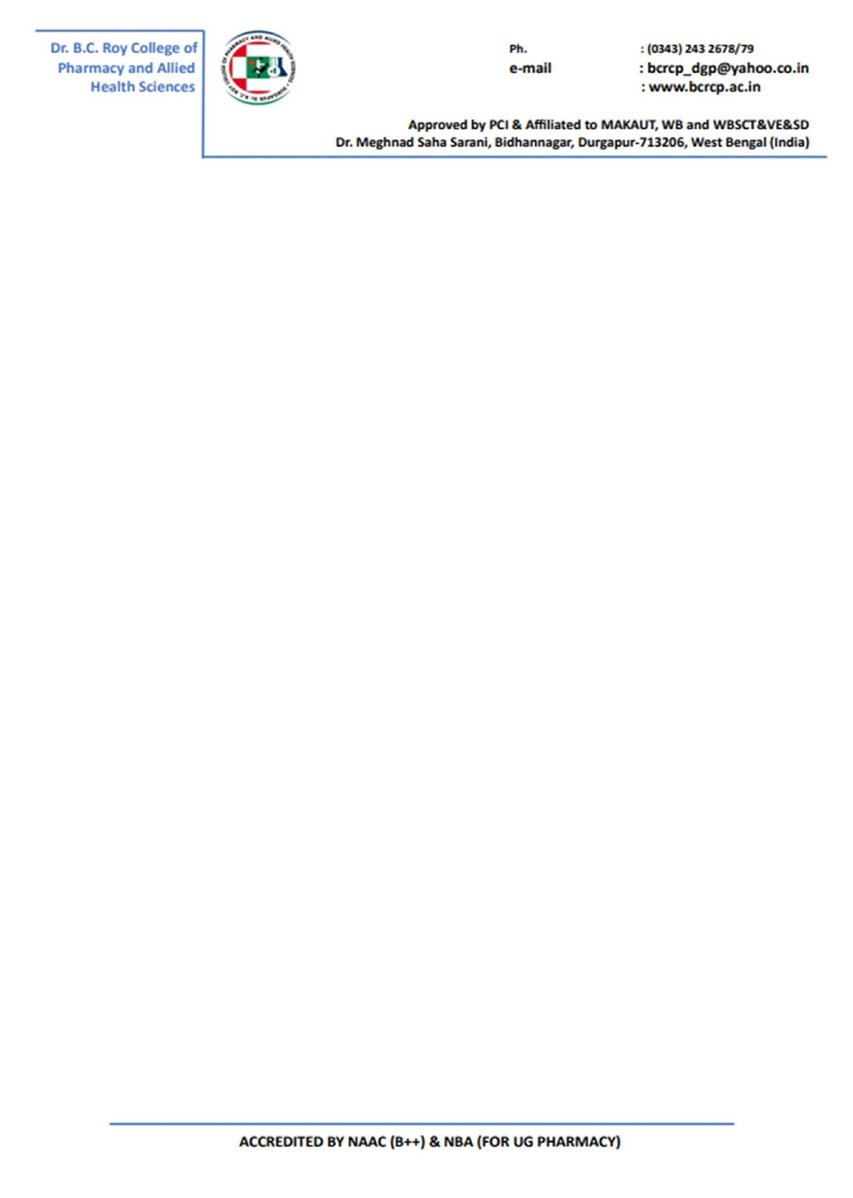

**ANNUAL GENDER SENSITIZATION ACTION PLAN**

**2022-2023**

● Being a co-educational institute, gender equality is one of the key aspects of the functioning of Dr. B. C. Roy College of Pharmacy & Allied Health Sciences (BCRCP).

● Gender-neutral policies are mediated through service rules, by-laws, code of conduct, disciplinary measures, career growth opportunities, roles and responsibilities, conduct of various events, administration to name a few.

● Gender sensitization is met through a systematic annual plan wherein gender issues are made aware for preventing discrimination. Some general followed practices include Celebration of Gender Equality Day, Women Rights’ Program functional Internal Complaints Committee (ICC), Anti-Discrimination Cell, Grievance Redressal Committee, Code of Conduct and Disciplinary Committee.

***ANNUAL GENDER SENSITIZATION ACTION PLAN*** *for AY 2022-2023 was planned to include*

* Celebration of **Women’s Equality Day** on 26 August 2022.
* A sensitization workshop for the employees and students of BCRCP on the occasion of International day for prevention of violence against women.
* Programmes on health awareness, health camps and Blood donation camp to understand potential roles of Pharmacist and Clinical Pharmacist irrespective of their gender.
* Yoga Classes for both for staff and students to keep mind and body toned.
* Awareness programmes on stress management and psychiatric problems for all.
* Participation of staff and students at state, national and international level workshops/seminars/conferences.
* Industrial visits and tours.
* Co-curricular and extracurricular activities to be designed and planned for students in and outside the campus to work in an integrated manner..
* Organizational skills and leadership skills of students to be developed inclusive of gender through organization of various programmes like Teacher's Day, Fresher's Day and Farewell Program.

**Gender Equity and Sensitization Programmes of BCRCP for AY 2022-2023**

| **Sl. No.** | **Title of Programme** | **Date** | **Details** | **Name of the Guest Faculty/Activity** |
| --- | --- | --- | --- | --- |
|  | Women Equality Day | 26th August 2022 | Celebrated by a parade by students holding banners to celebrate the theme. | Prof S. Chakraborty Director BCRCP |
|  | Biswakarma Puja | 17th September, 2022 | Both boys and girls equally participated in arranging the puja festivities | NA |
|  | World Peace Day | 21st September, 2022 | Students formed a peace parade holding hands and displayed a video documentary on the importance of this day. | NA |
|  | Interactive Session | 21st October 2022 | An interactive session was held on stress management and psychiatric problems for students. | Dr. Anurupa Ganguly, Psychological Counsellor, The Mission Hospital, Durgapur |
|  | International day for prevention of violence against women | 25th November 2022 | **Sensitization worksho**p for the employees & students to make them aware of the provisions of The Sexual Harassment Of Women At Workplace (Prevention, Prohibition And Redressal) Act, 2013.  A **pukwara** on prohibition to sexual harassment to women carried out where students actively participated in **various activities like elocution**  **(Topics:**  **i)** navigatingthrough career and motherhood**,**  **ii)** should women stay at home to raise their children,  **iii)** men are better in decision making roles than women,  **iv)** saluting women’s contribution to society, v) lack of women in position of power,  **vi)** should women be blamed for any mishappening that she was ill-dressed or over-smart);  and **essay competitions** on the **topic** “Women’s day: Building a better place to live in”. | **Dr. Taniya Chakraborty,** an educationist, counsellor and Personal Grooming coach of Dr. B. C. Roy College of Engineering, |
|  | Pharmacy Week | 24th -25th November 2022 | Free health check-up camp was conducted for the needy in joint collaboration with Pharmacist Association, West Bengal, Paschim Bardhhaman.  Dr. Dhiman Mandal, Superintendent, S.D. Hospital, Durgapur, Chief Guest delivered a talk on the importance of National Pharmacy week. | Dr. Dhiman Mandal, Superintendent, S.D. Hospital, Durgapur |
|  | National Youth Day | 11th January 2023 | Speech by dignitories and pledge taken by students.  Video documentary by students. | NA |
|  | Saraswati Puja | 26th January 2023 | Both boys and girls equally participated in arranging the puja festivities | NA |
|  | SPER International Conference and Exhibition 2023 | 24th -25th March 2023 | Students equally participated in the conference along with faculty and staff by organizing the event and also participating in scientific sessions conducted. | (Chief Guest) Prof. (Dr.) Suhrita Paul, Vice-Chancellor, The West Bengal University of Health Sciences, Kolkata, West Bengal |
|  | Technical Fest  Cultural Fest  Fresher’s day  Farewell | 9th -12th May 2023 | Both boys and girls equally participated in arranging the events and took part in various competitions held during the events. | Albert Kabo, Subhashree Debnath |