MEDICINAL PLANT GARDEN AT A GLANCE
MEDICINAL PLANT GARDEN ZONE
ZONE-1 | ZONE-2
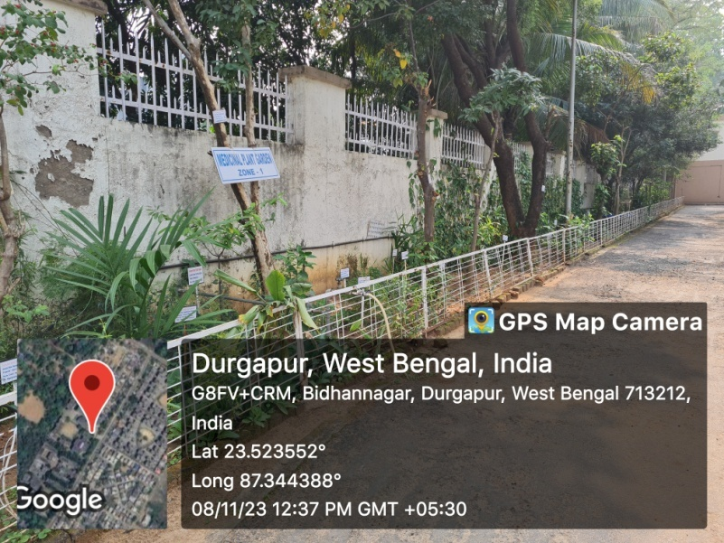 | 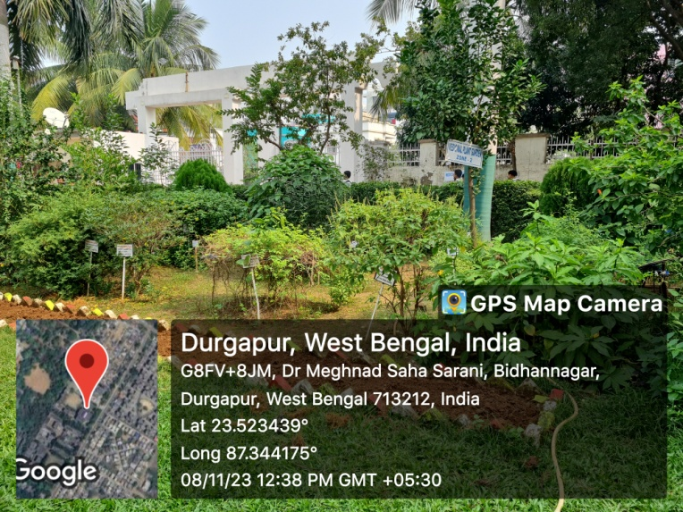
ZONE-3 | ZONE-4
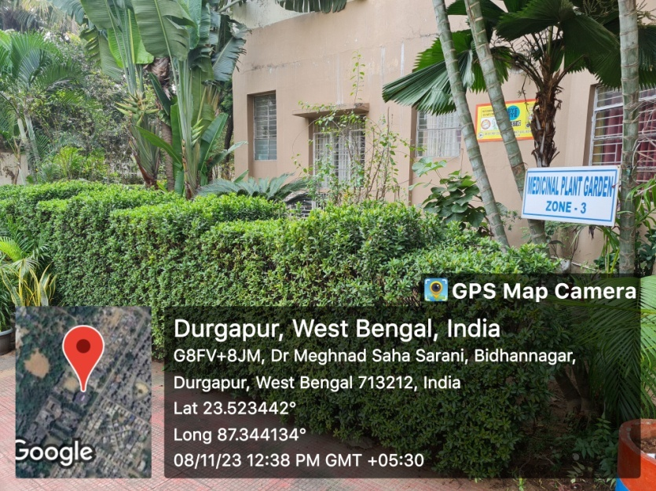 | 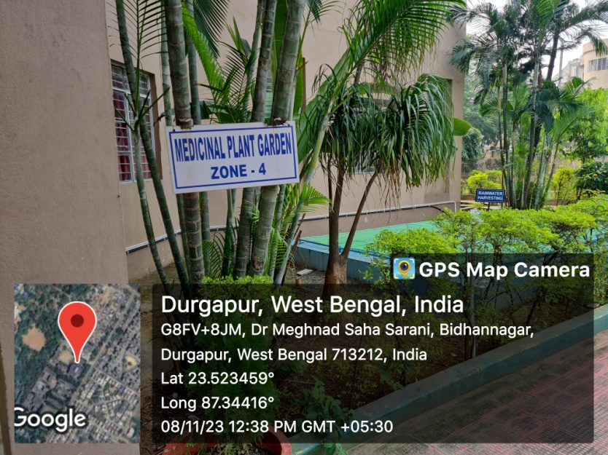
ZONE-5
