COMPUTING EQUIPMENT AT A GLANCE
CC TV
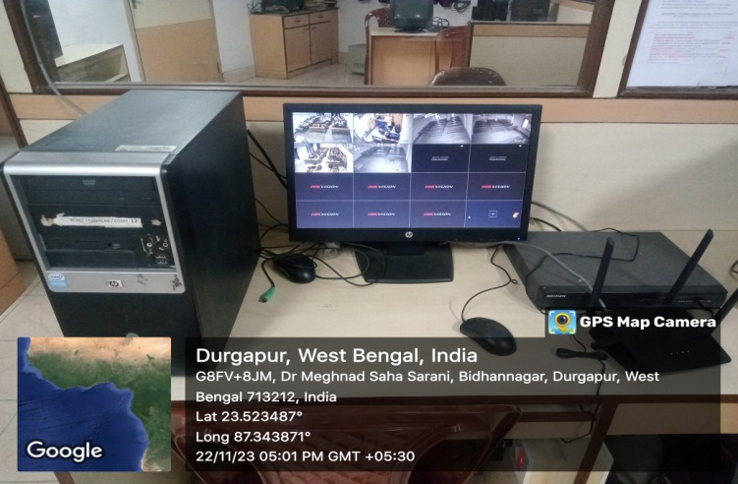 |  |  |  | 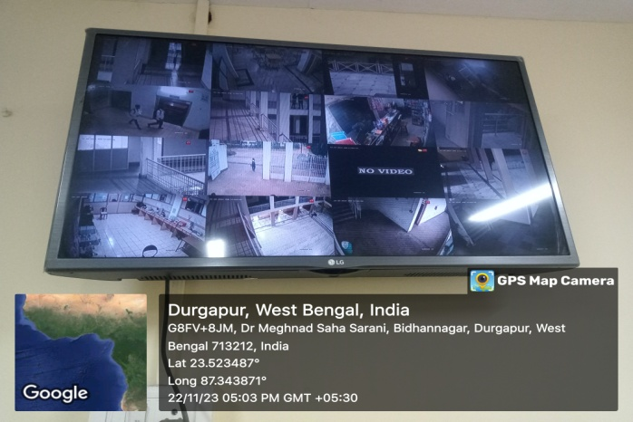
COMPUTER CENTER/SIMULATION LAB
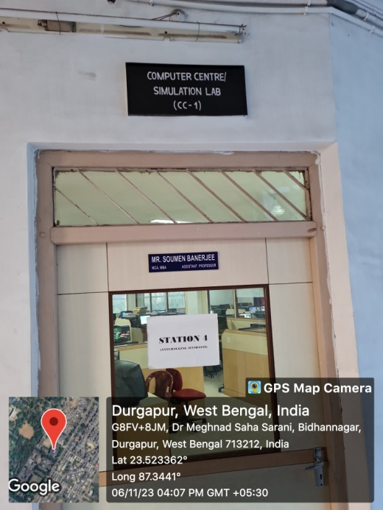 |  | 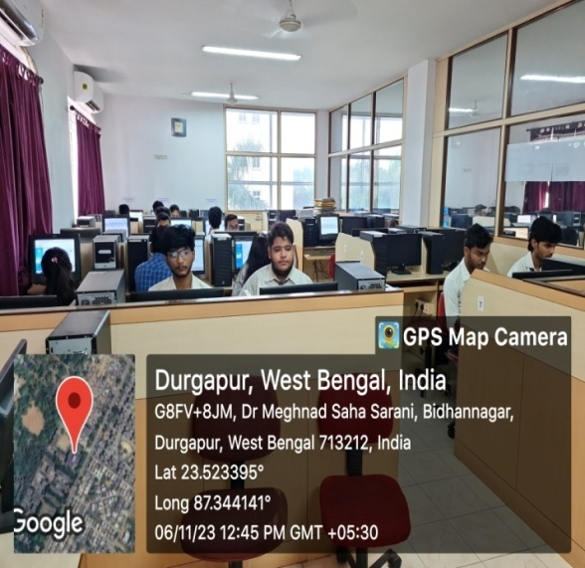 |  |  |  | 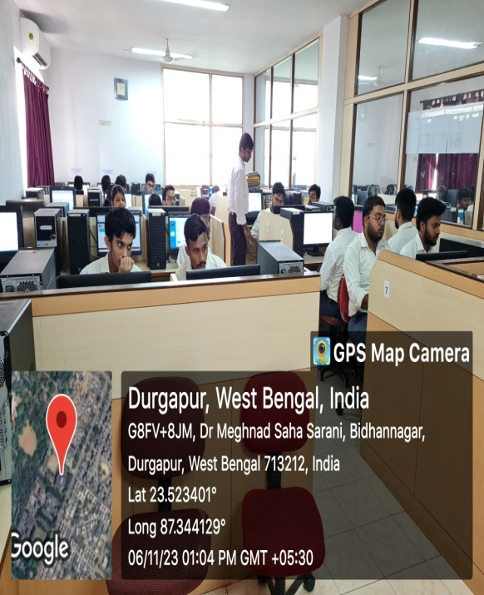
PHARMACOLOGY SIMULATION LAB
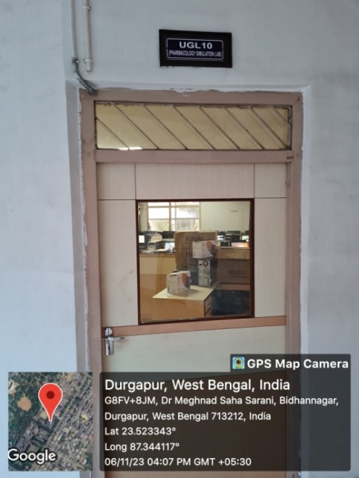 | 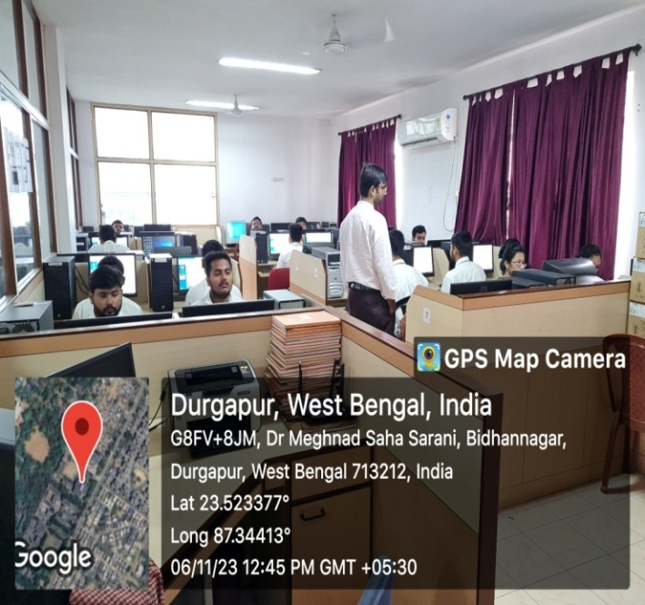 |  |  |  | 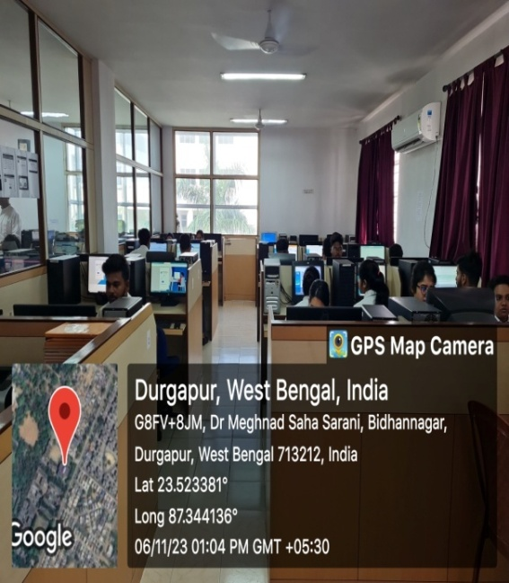
SIMULATION/ LANGUAGE LAB
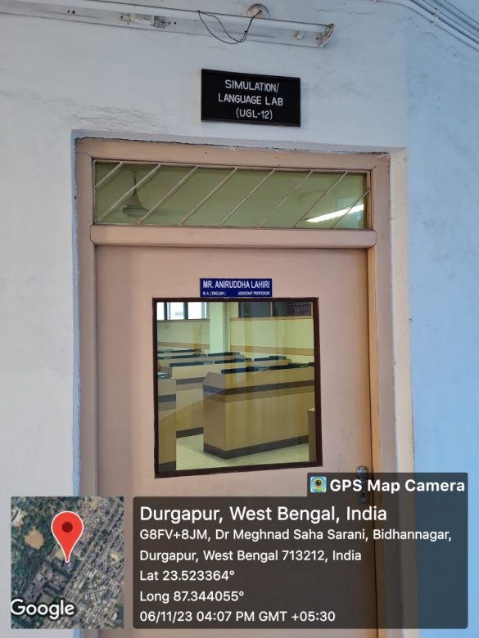 | 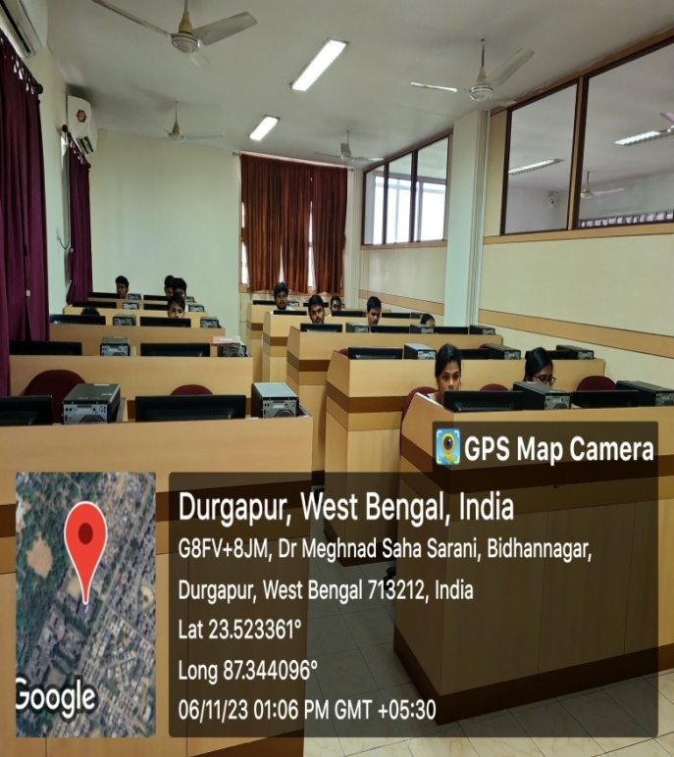 |  |  |  | 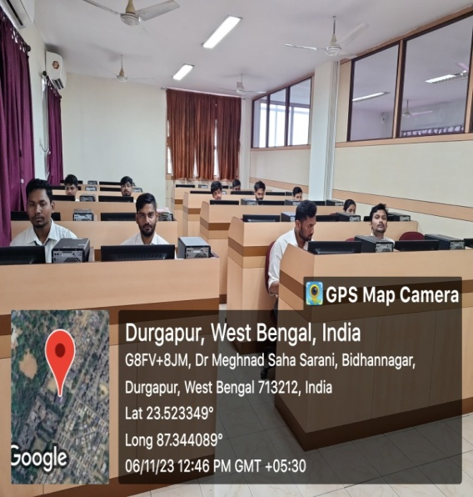
SOPHISTICATED INSTRUMENTS
HIGH-PERFORMANCE LIQUID CHROMATOGRAPHY |  |  | IR SPECTROPHOTOMETER
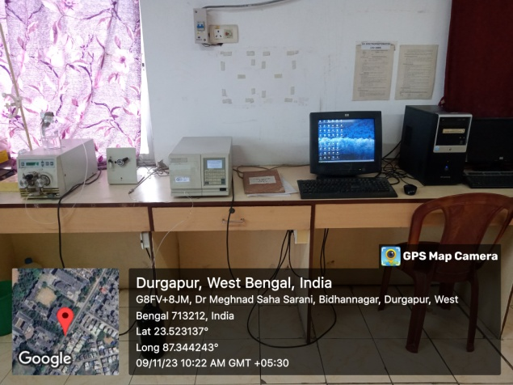 |  |  | 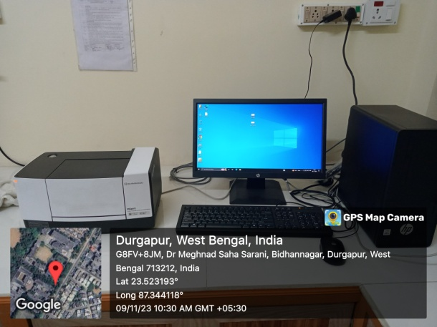
UV-VISIBLE SPECTROPHOTOMETER |  |  | COMPUTING_PRINCIPAL_OFFICE
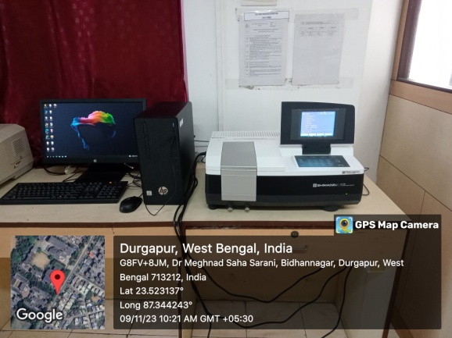 |  |  | 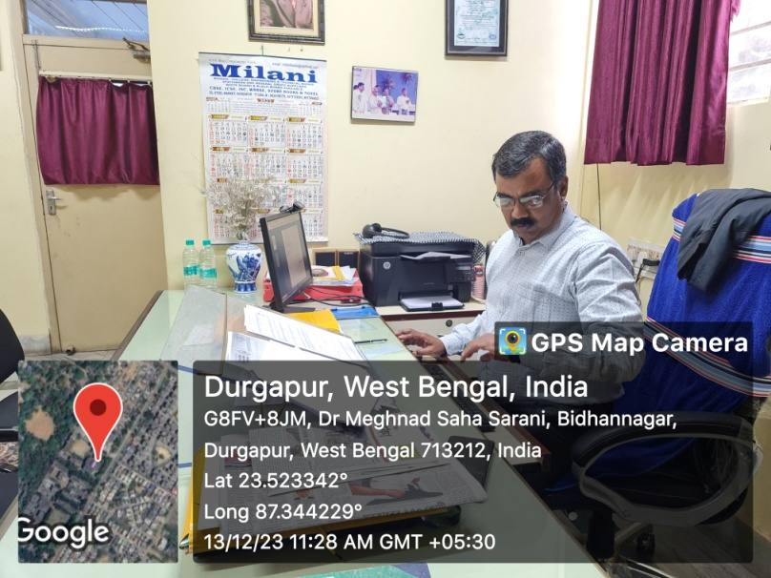
COMPUTING_ADMIN |  |  | COMPUTING_EXAM
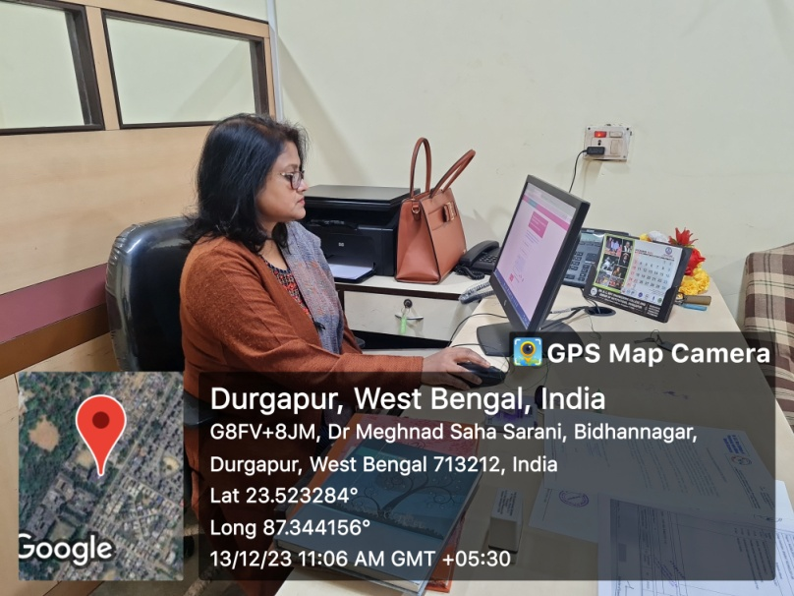 |  |  | 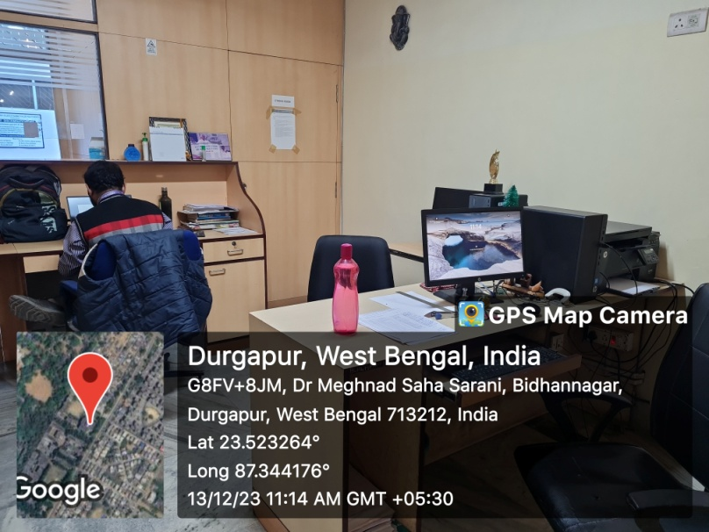
COMPUTING_LIB |  |  | COMPUTING_DOCKING
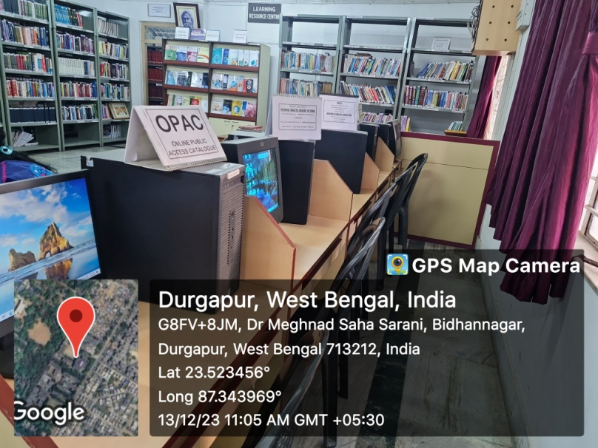 |  |  | 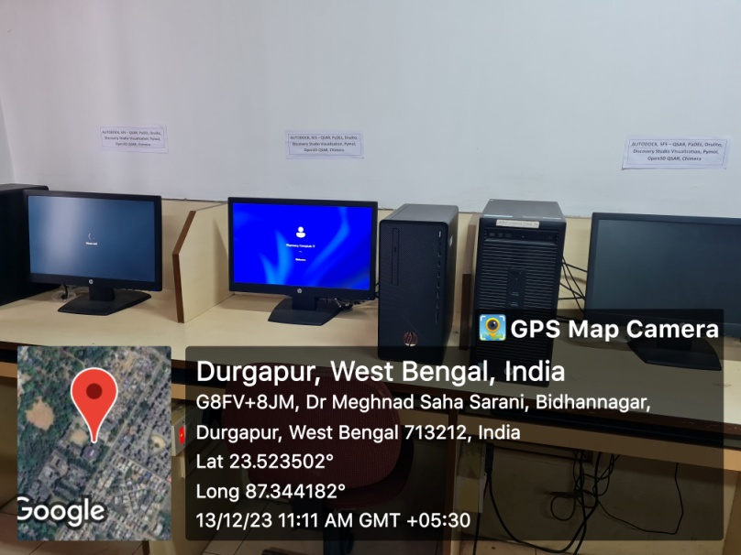
COMPUTING_IQAC |  |  | COMPUTING_IQAC_1
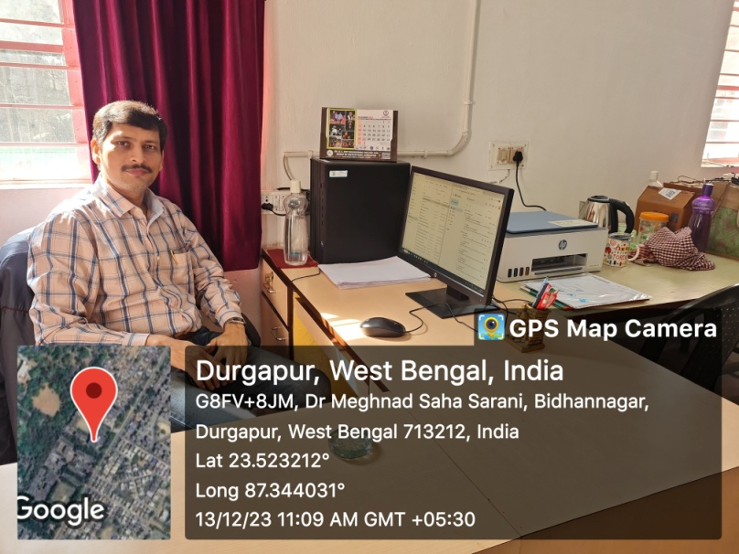 |  |  | 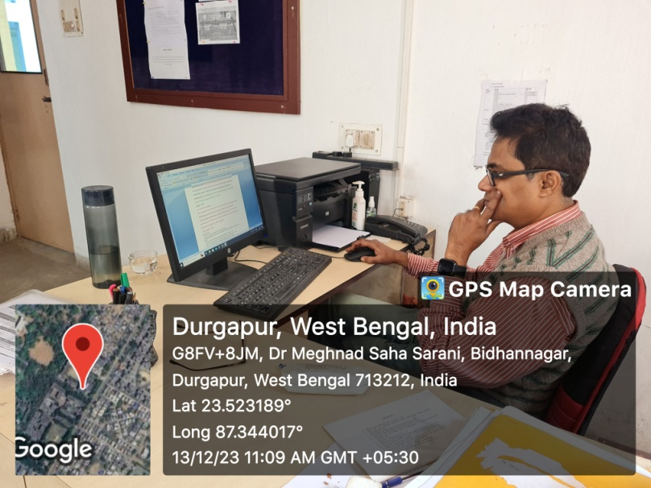
COMPUTING_AO |  |  | COMPUTING_AO_1
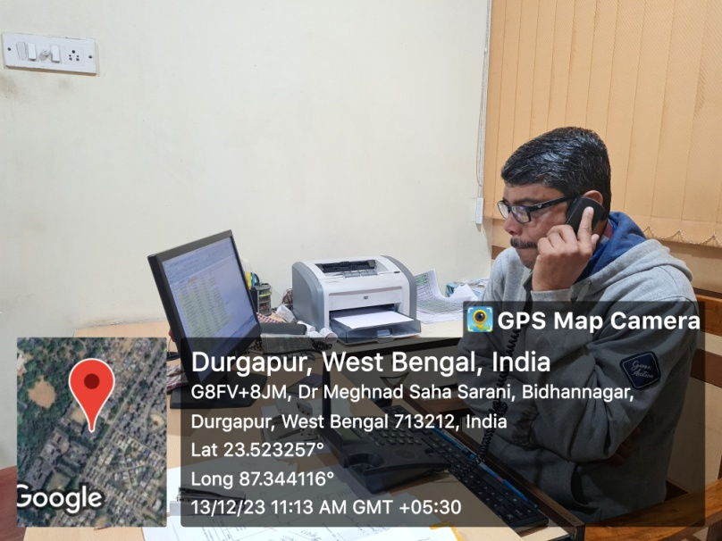 |  |  | 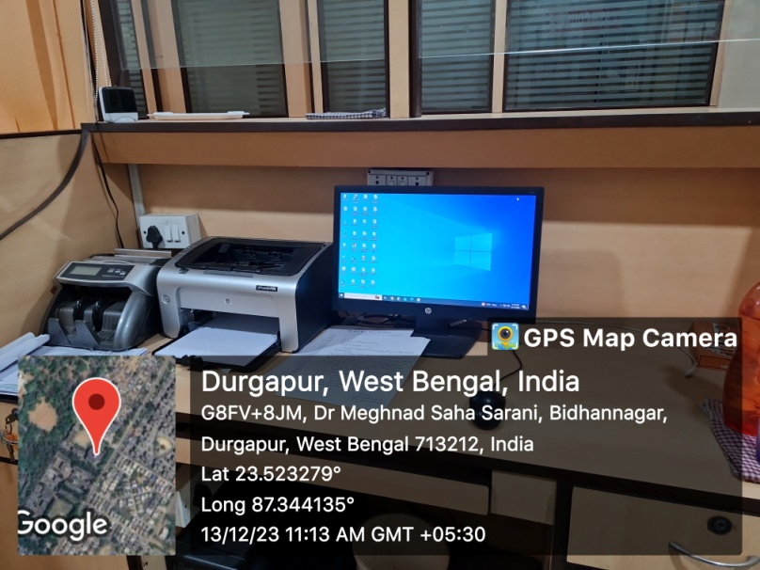
COMPUTING_INCHARGE
